Vehicle classification from scratch using cnn

Vehicle detection is a problem can be used in object detection while on road. We are solving such a problem using convolutional neural network. Already images been collected from Kaggle in 256x256 format in RGB

Dataset

* Data collected from Kaggle is [car images](https://www.kaggle.com/datasets/mdsagorahmed/car-images)
* Dataset contains 7 types of vehicles out of which 6 are used ie rikshaw,bycycle,car,motorbike,taxi,car
* Images are in 256x256x3
* It containg all the types of vehicle images in separate folder with label
* Contain 2297 images in total in jpg and 10.14mb

Neural network architecture

* It containing 3 convolutional layer and 2 maxpooling and one flatten layer
* Activation function used is relu
* 10 epocs are used here

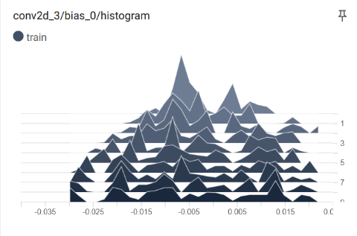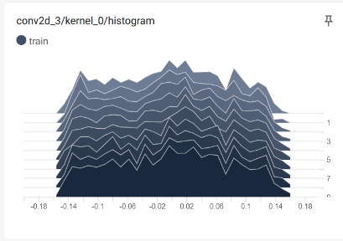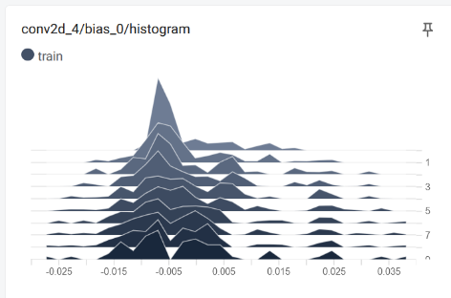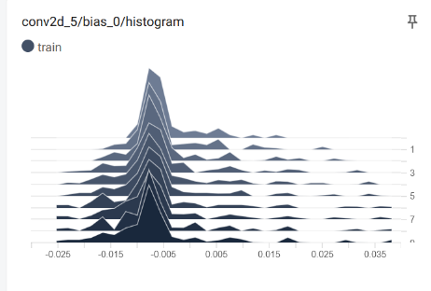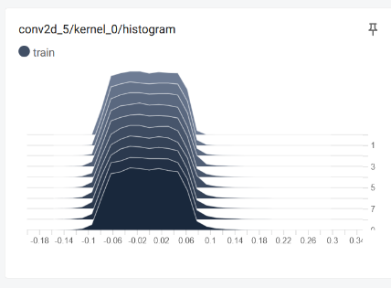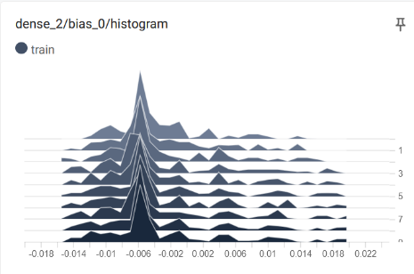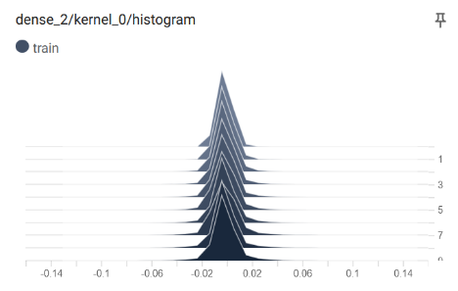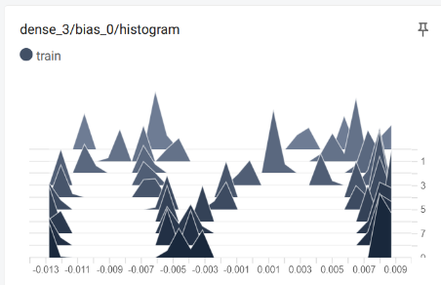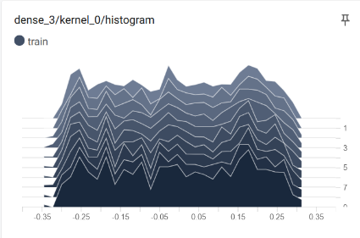

* Final accuracy is 99.87%

